
IOWA SNOWDRIFTERS
GOLDSMITH-RINEHART MEMORIAL SCHOLARSHIP
This scholarship was established in the memory of Gary Goldsmith and Melvin Rinehart,
two outstanding club and board members.
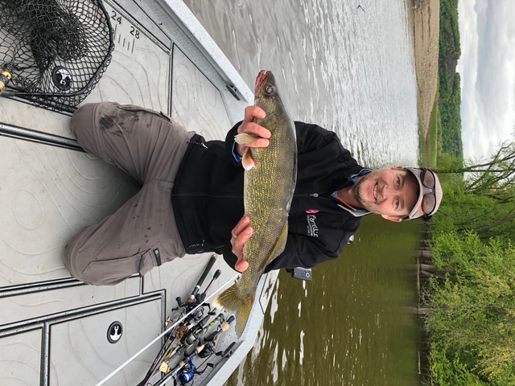
ELIGIBILITY CRITERIA
- Applicant must be enrolled in or accepted to attend an accredited two-year college, an accredited four-year college or university, or an accredited proprietary vocational school.
- All applicants must be a current member or the son or daughter of a member of the Iowa Snowdrifters Snowmobile Club.
- The application form must be complete in all respects and the committee must receive all required supporting material before the application deadline. The application must be accompanied by the following documents:
- A copy of the most recent academic grades.
- A typewritten essay illustrating “What Snowmobiling Means to You.” The content of this essay should be a minimum of 300 words and a maximum of 500 words in content. Please reference your personal participation, or ways you have contributed to the efforts of the club.
- Two recent photographs of applicant.
4. Further guidelines include the following:
- All written correspondence must be on 8 ½”x11” paper; typed.
- The importance of well thought out essays cannot be over emphasized (including good grammar and spelling) in filling out your application for this scholarship.

DEADLINE
Applications for the scholarship shall be submitted by May 1 of the year for which the scholarship is requested, to be awarded for the upcoming fall semester.

AWARDS
The Iowa Snowdrifters board members, or persons designated by the committee, will judge all applications and determine the qualified recipients. Applicants may be interviewed. Iowa Snowdrifters will award up to three - $500 awards. Winners will be notified by mail and/or phone. Recipients are required to provide proof of enrollment to receive award. The board reserves the right to increase the number of awards pending funds available.

MAILING INSTRUCTIONS
The application and all supporting materials must be mailed to:
Snowdrifters Inc.
PO Box 5735
Coralville, IA 52241

This application must be dated and returned to this address by the May 1 deadline.

IOWA SNOWDRIFTERS
GOLDSMITH-RINEHART MEMORIAL SCHOLARSHIP
APPLICATION

Student’s Name:_____________________________________________________________________
Address:___________________________________________________________________________
City:___________________________________________State:_____________Zip:______________
Home Phone:________________ Cell Phone:________________ Work Phone:__________________
Email:_____________________________________________________________________________
Name of High School:________________________________________________________________
Graduation Date:____________________________________________________________________
What is your high school G.P.A.?________
Parent(s)/Guardian(s):________________________________________________________________
Address: ___________________________________________________________________________
City: ___________________________________________State:______________Zip:_____________
Home Phone: __________________ Cell Phone: _________________ Work Phone: _______________
Are you or your family a member of a snowmobile club? ____yes _____no
Snowmobile Club Name: ______________________________________________________________
Club President Name: _________________________________________________________________
Club President’s Phone Number: ________________________________________________________
Institution you have chosen to attend? ____________________________________________________
Intended major or vocational field? ______________________________________________________
College Student ID # : ________________________________________________________________

____________________________________________________ _______________________
Applicant Signature Date
By submitting this application, I certify that the information contained therein is correct to the best of my ability and understand that false information omission of data may result in denial of the application. By signing this application and if selected as a scholarship recipient, I give permission to the Iowa Snowdrifters. to use my photo solely for the purpose of club marketing materials.

For questions or for more information, contact Chris Stebral at (319) 551-3767 or via email at cstebral@constructionmaterialsinc.com

IOWA SNOWDRIFTERS
GOLDSMITH-RINEHART MEMORIAL SCHOLARSHIP

List below the extra-curricular activities you have participated in during high school. Include activities outside of school as well as in school.

List any other special awards, recognition, or accomplishments you have achieved during high school.

Describe any work or other barriers, which may have limited your involvement in activities.

In a short statement, describe the impact your School and Community has had on you as an individual. Describe how you and your family would benefit from this scholarship. Be sure to tell why you feel you need monetary help for college.

Please type an essay illustrating “What Snowmobiling Means to You.” The content of this essay should be a minimum of 300 and a maximum of 500 words in content. (Use a separate sheet if necessary.)

